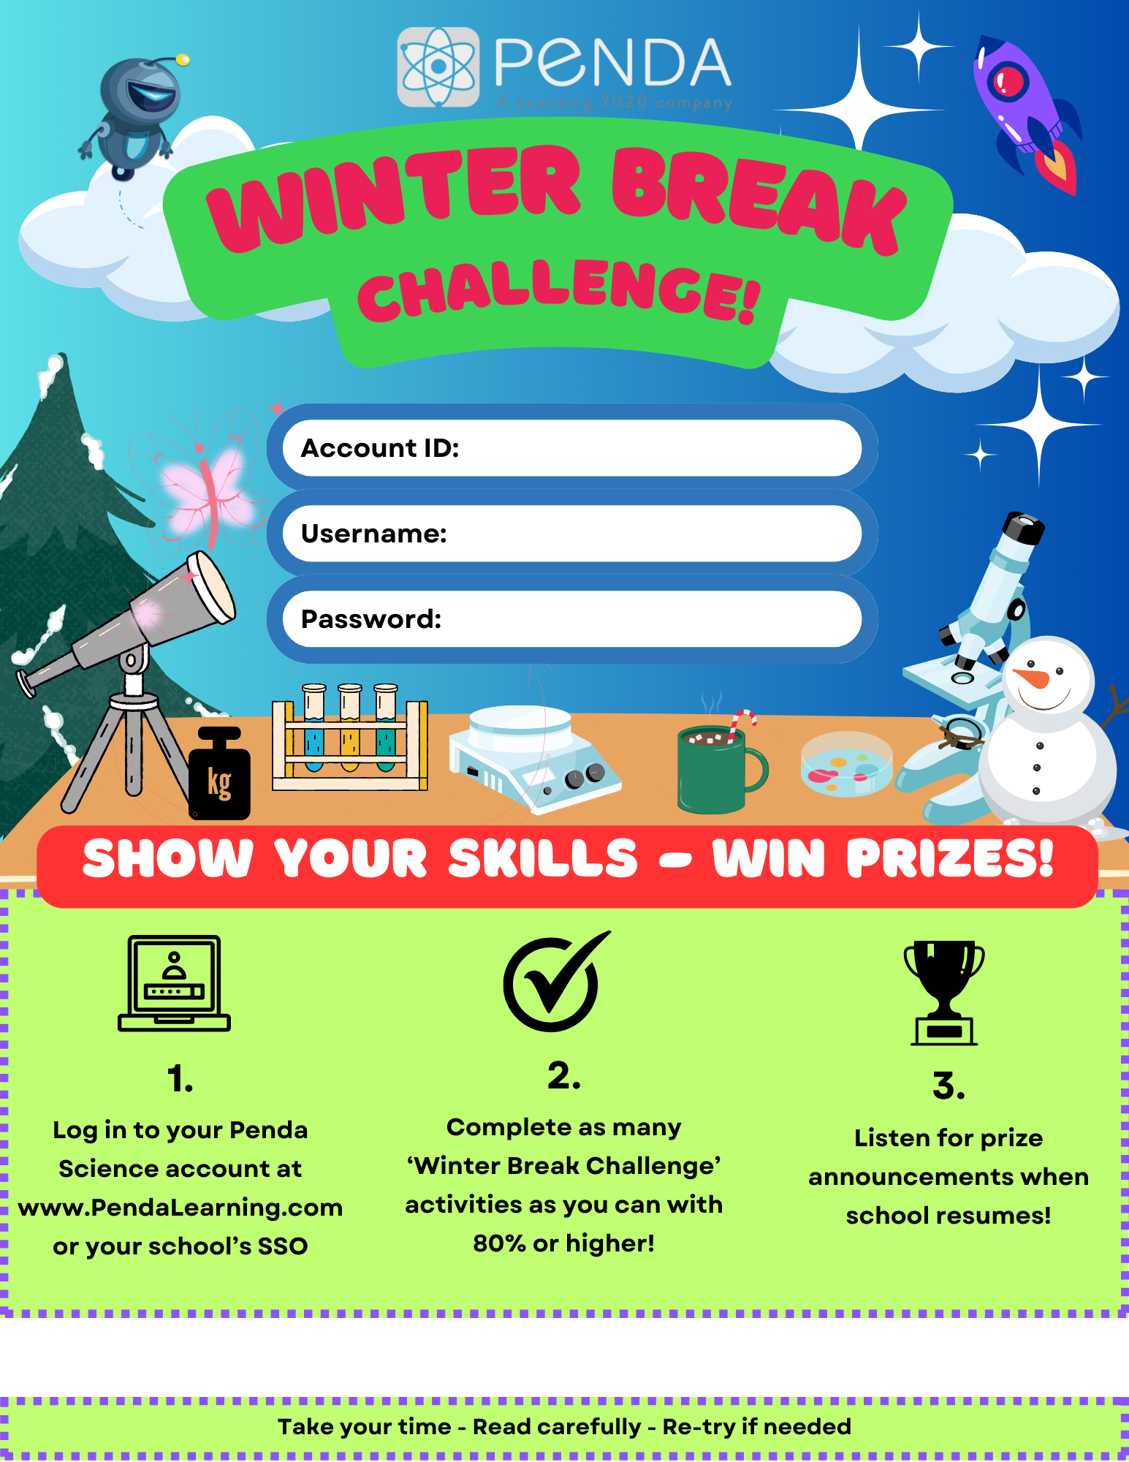

<REPLACE WITH YOUR ACCOUNT ID>

< REPLACE WITH USERNAME FORMAT>

<REPLACE WITH PASSWORD FORMAT>

**< REPLACE W/YOUR DATES: RUNS 12/18 @ 3:00 PM – 1/5 @ 11:59 PM>**