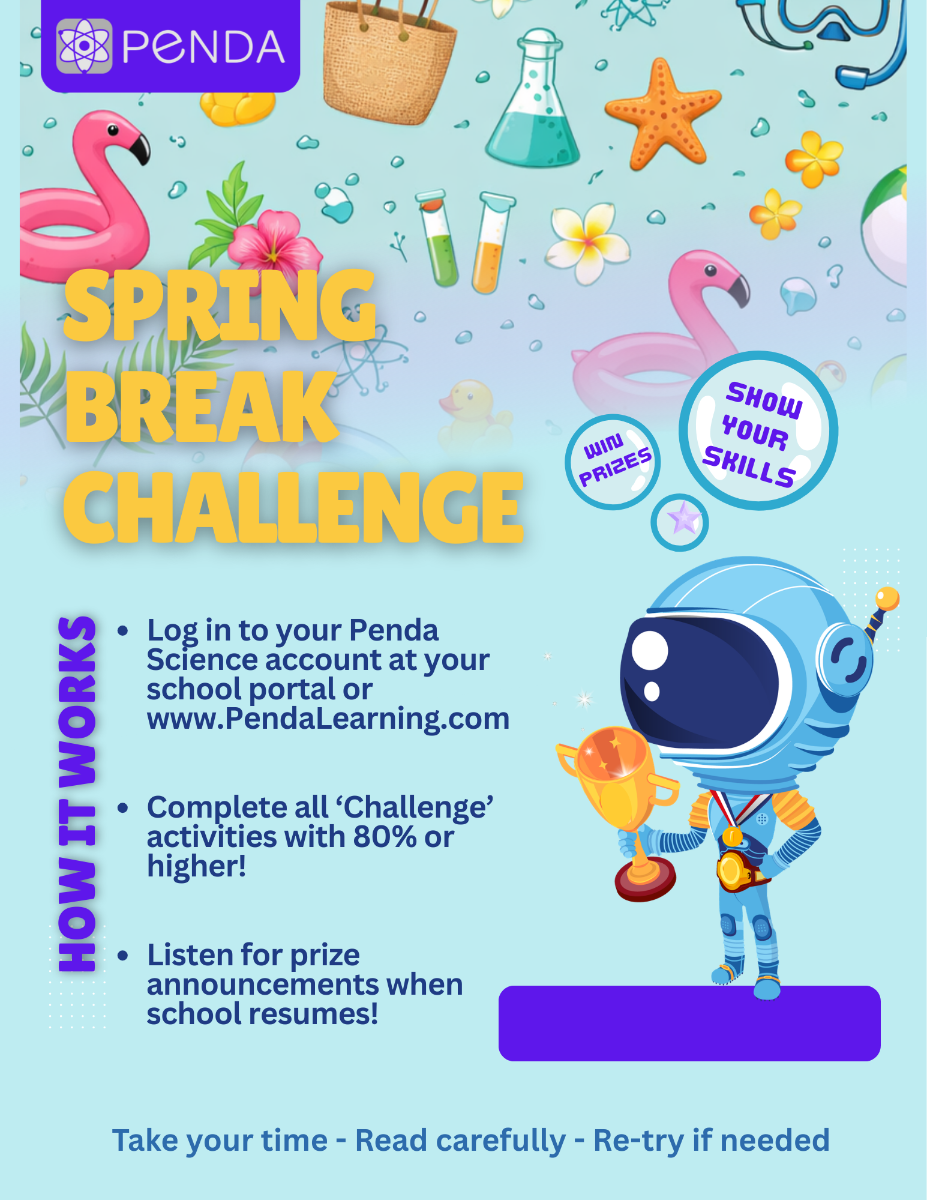
{MAR 14 – MAR 23}

