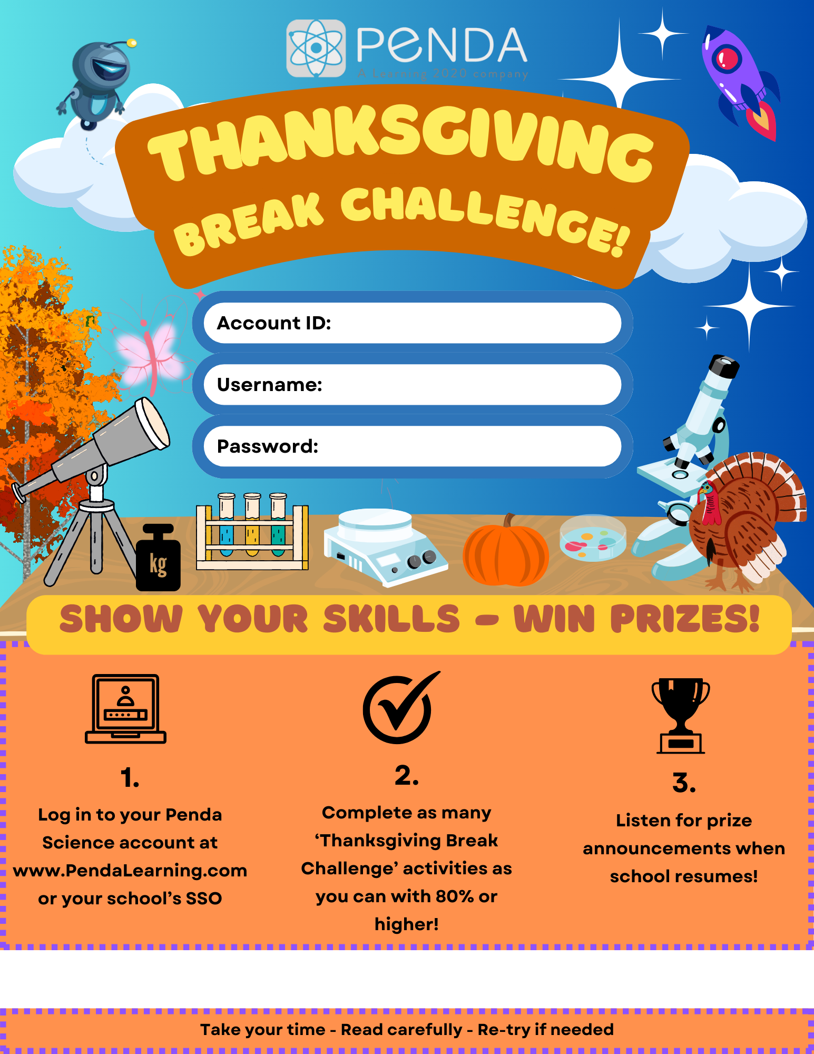
< REPLACE W/YOUR DATES: RUNS 11/27 @ 3:00 PM – 12/1 @ 11:59 PM>
<REPLACE WITH PASSWORD FORMAT>
< REPLACE WITH USERNAME FORMAT>
<REPLACE WITH YOUR ACCOUNT ID>

