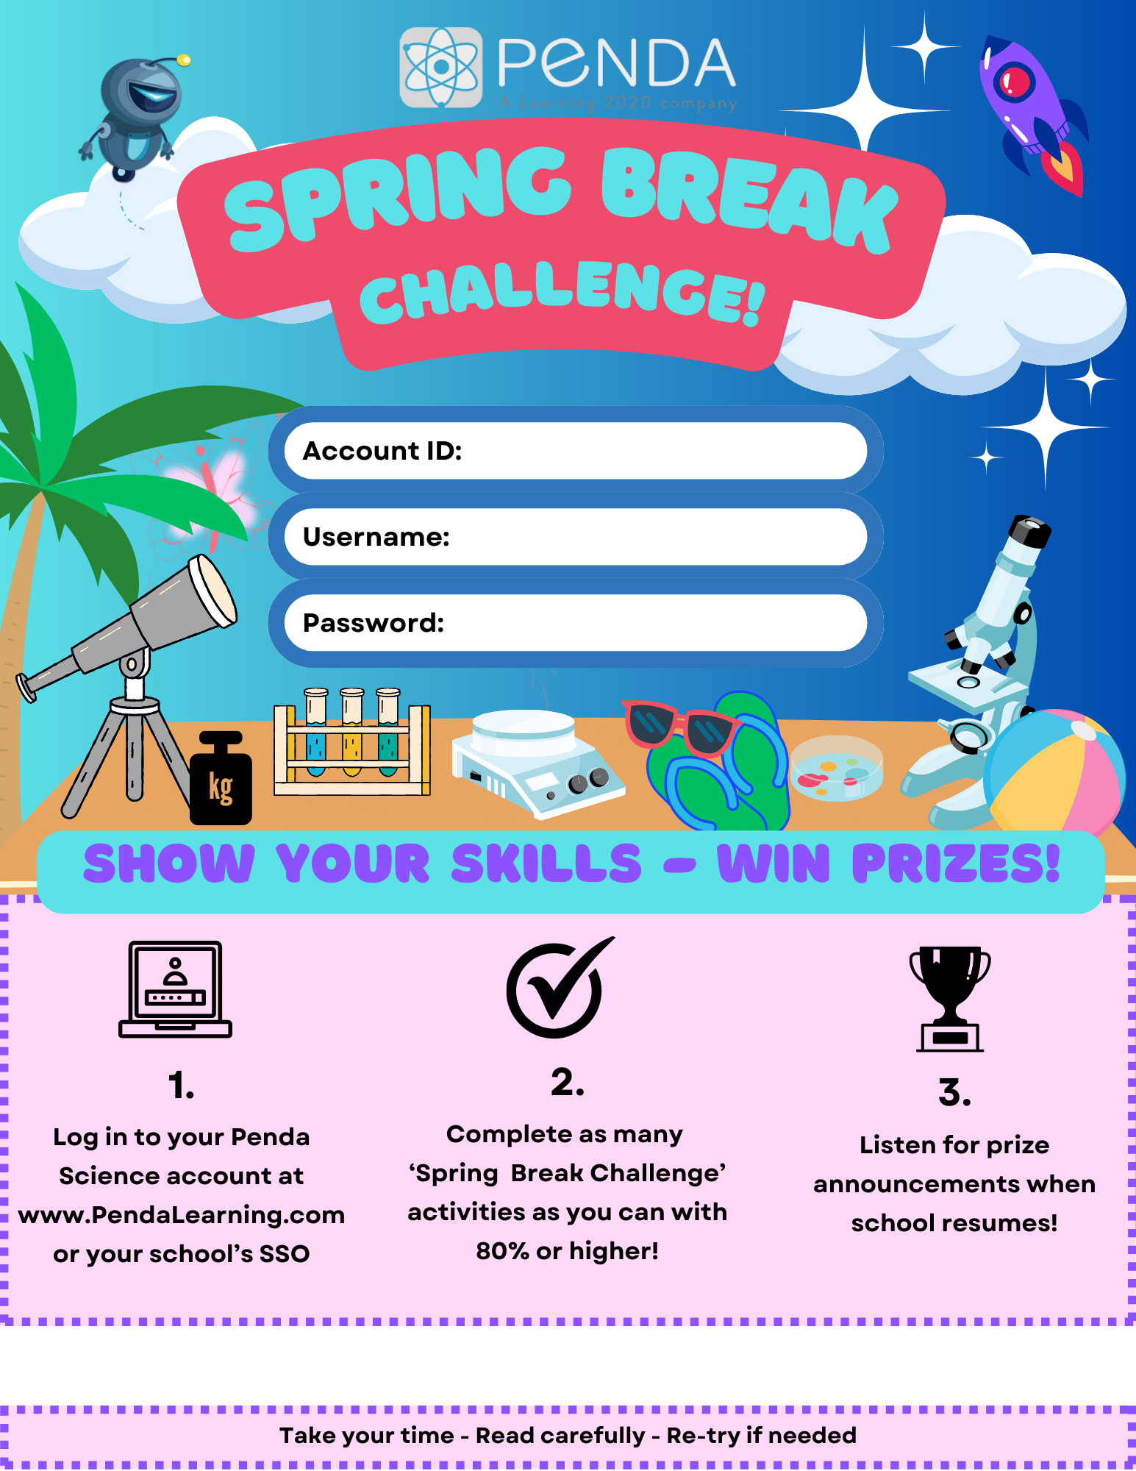

< REPLACE W/YOUR DATES: RUNS 4/4 @ 3:00 PM – 4/13 @ 11:59 PM>
<REPLACE WITH YOUR ACCOUNT ID>
< REPLACE WITH USERNAME FORMAT>
<REPLACE WITH PASSWORD FORMAT>

