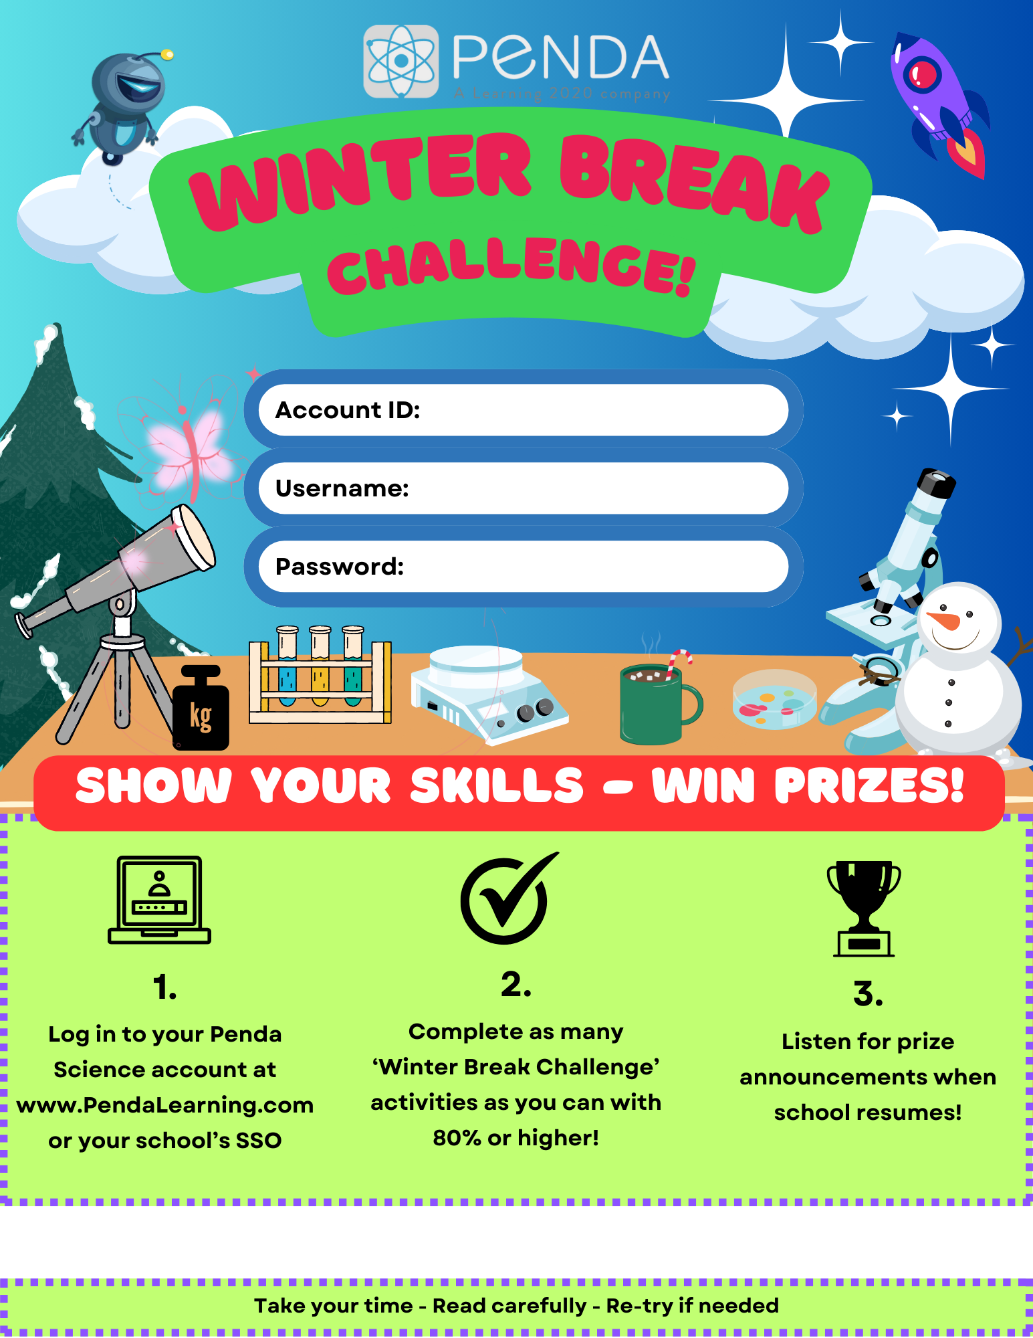
<REPLACE WITH YOUR ACCOUNT ID>
< REPLACE WITH USERNAME FORMAT>
<REPLACE WITH PASSWORD FORMAT>
< REPLACE W/YOUR DATES: RUNS 12/18 @ 3:00 PM – 1/5 @ 11:59 PM>

