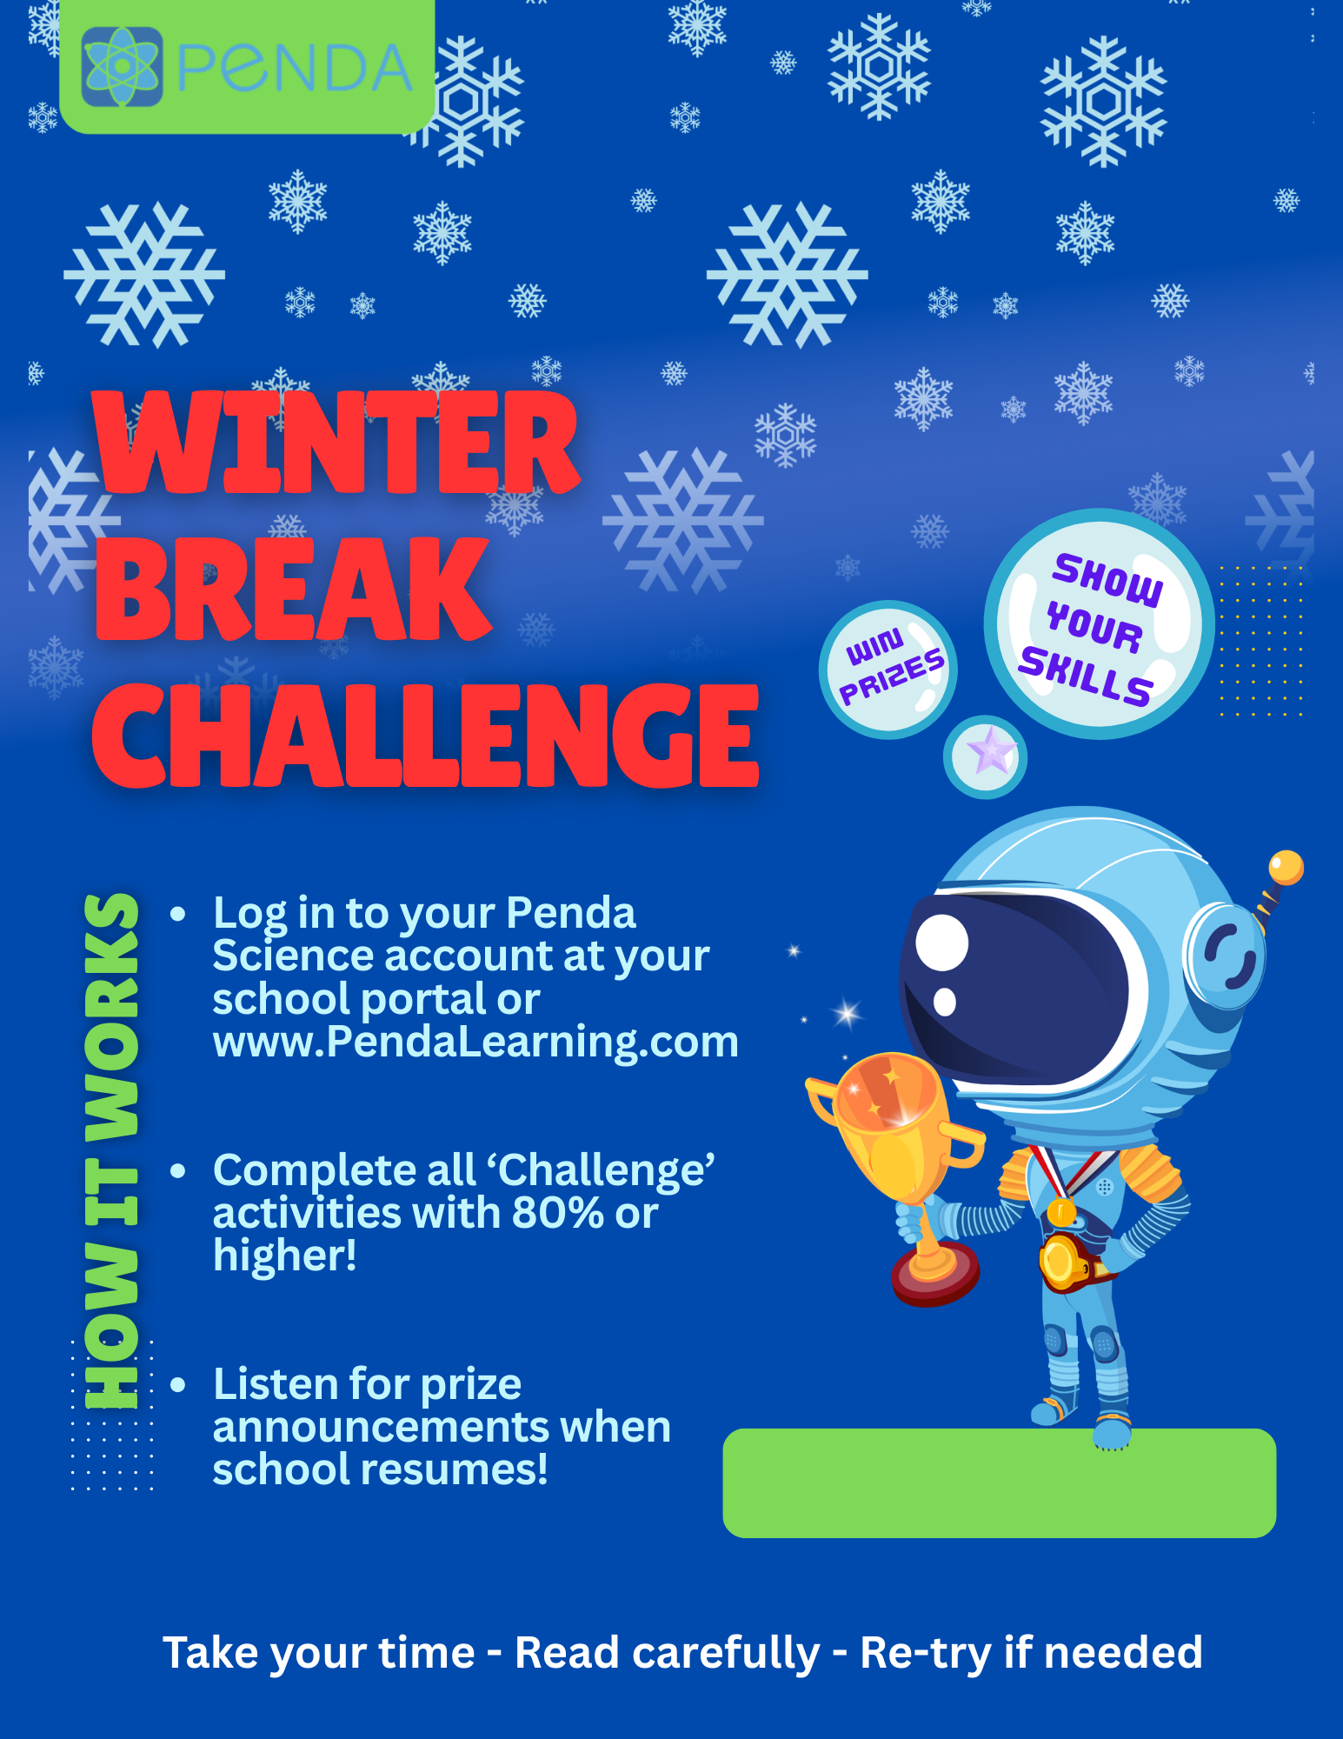

{DEC 19 – JAN 4}

