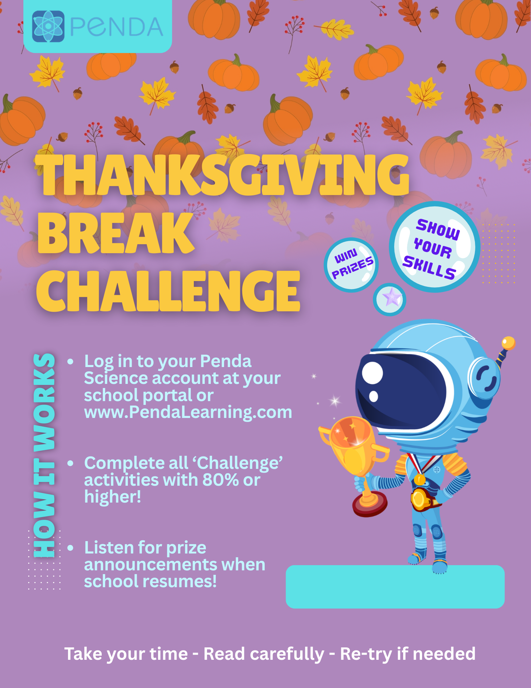
{NOV 23 – NOV 27}

