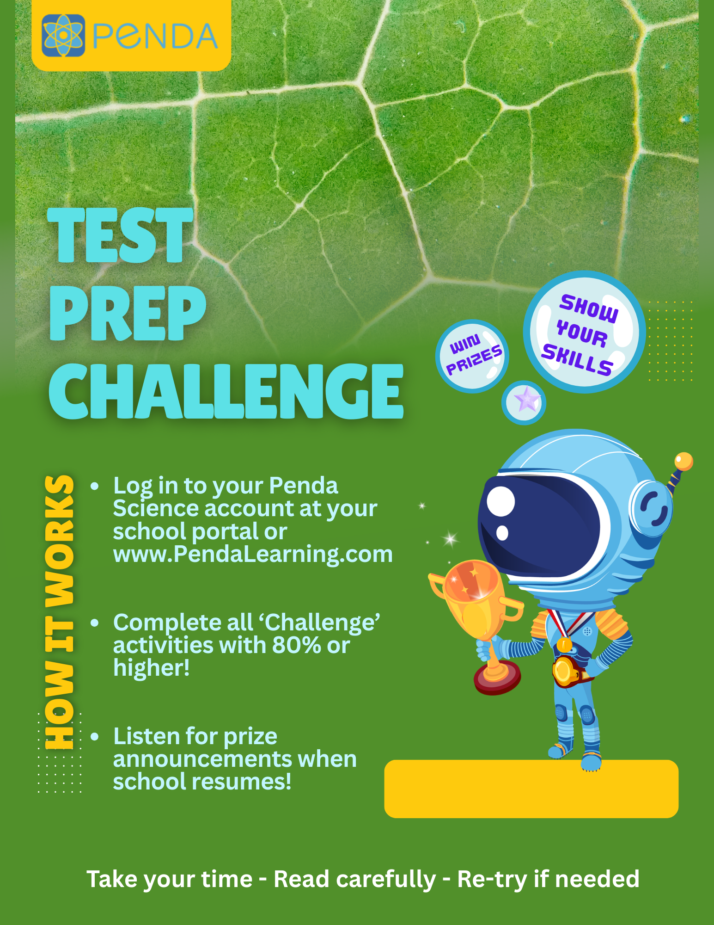
{APR 7 – MAY 5}

